**Some explanations for my game system:**

There are four games in all: connect4, TOOT, TOOT2 and connect5. (TOOT and TOOT2 are similar. I wrote them with two different rules.)

“project_main.java” is the entry for all the games.

“main.java”, “connect4winner.java”, “randomai.java” and “smartai.java” are for the game “connect4”

“simpletoot.java”, “simpletootwinner.java” and “simpletootrandomai.java” are for the game “TOOT”. (The rule is: when there is “TOOT” on the board, red wins; when there is “OTTO” on the board, yellow wins.)

“mainfortoot.java”, “tootwinner.java”, “randomaitoot.java” are for the game “TOOT2”. (The rule is: when there is “TOOT” on the board with red color, red wins; when there is “OTTO” on the board with yellow color, yellow wins.)

“connect5.java”, “connect5winner.java” and “randomaiconnect5.java” are for the game “connect5”.(The difference from connet4 is: player can put chess piece in any place of the board, and need to connect five chess pieces.)

**Overview of the game implementation:**

This is the entry for all games. You can:

1. Enter the game you want to play by clicking on the game name;
2. Exit the process by clicking “exit”

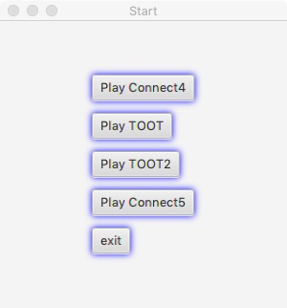

Let’s click “Play Connect4”.

Now we enter the game. You can:

1. Enlarge the game board by clicking “Add Grids”;
2. Choose the game mode: play with a person/random AI/smart AI;
3. Go to the entry page by clicking “reset”;
4. Place your chess by clicking on the white circle;
5. If you want to cancel your move and go to the last step, click “regret”.

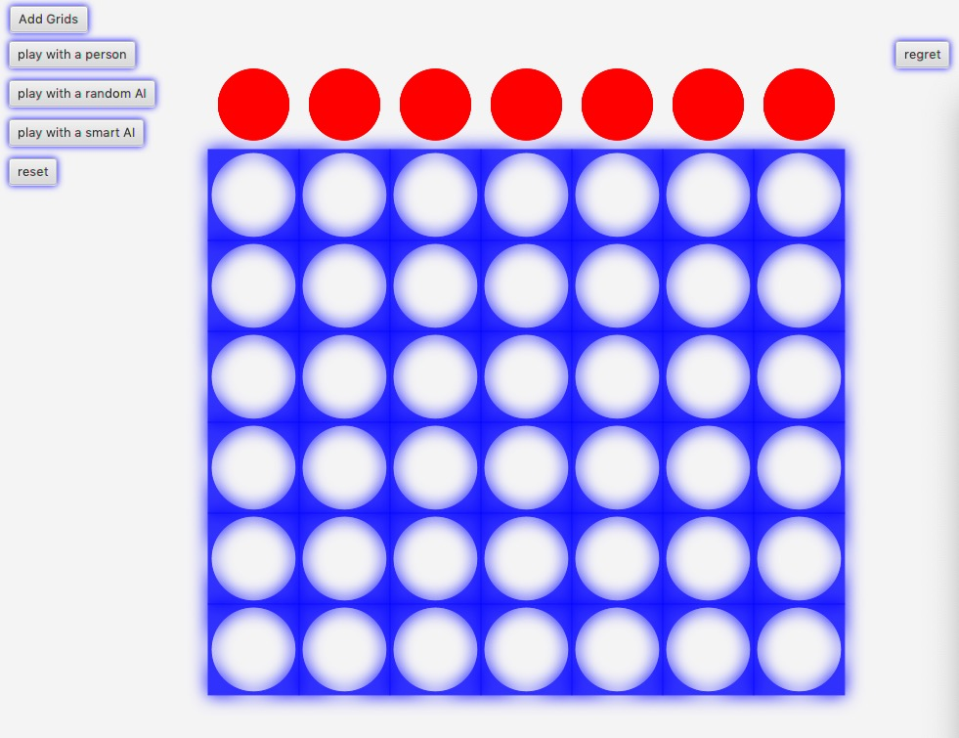

Let’s place a chess.

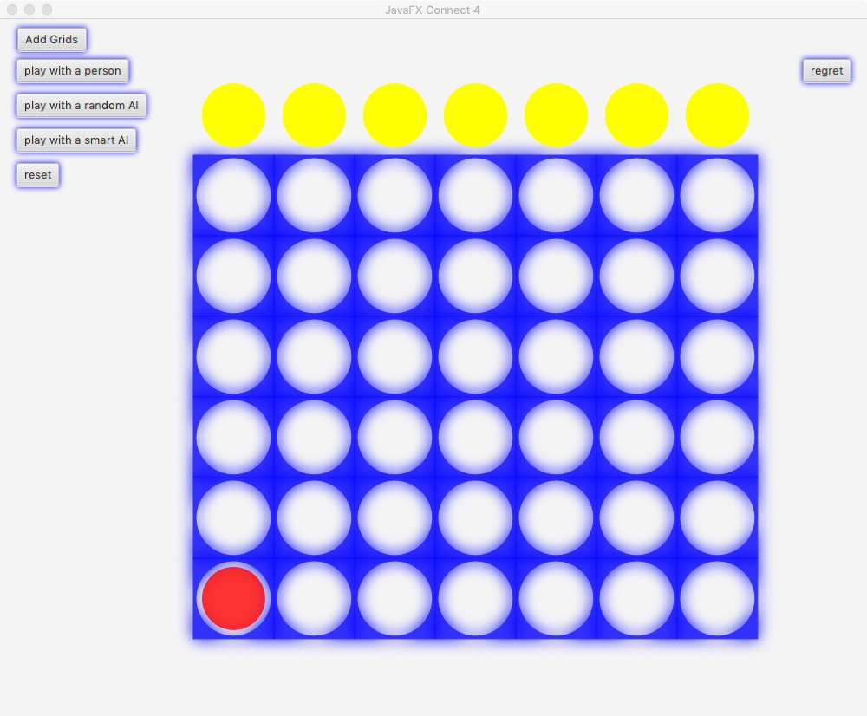

Now it’s the opponent’s turn.

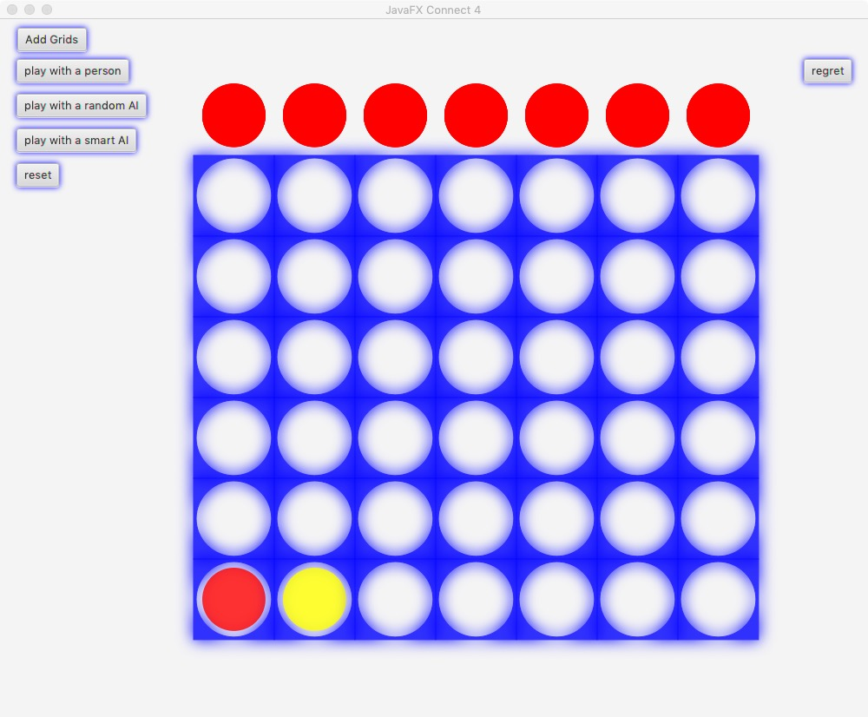

The opponent wins!

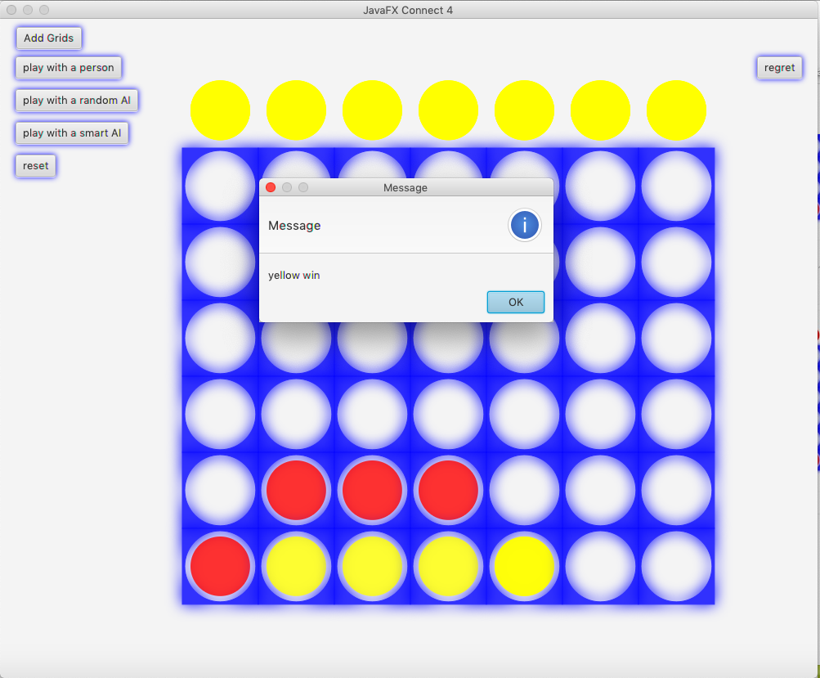

Let’s play with an AI.

Every time you place a chess, the AI will take its turn automatically.

The AI wins!

Now let’s reset and play TOOT.

The operations are similar, but don’t forget to choose the character(“T” or “O”) you want to use before placement. In this case, I placed a “T”.

Red wins!

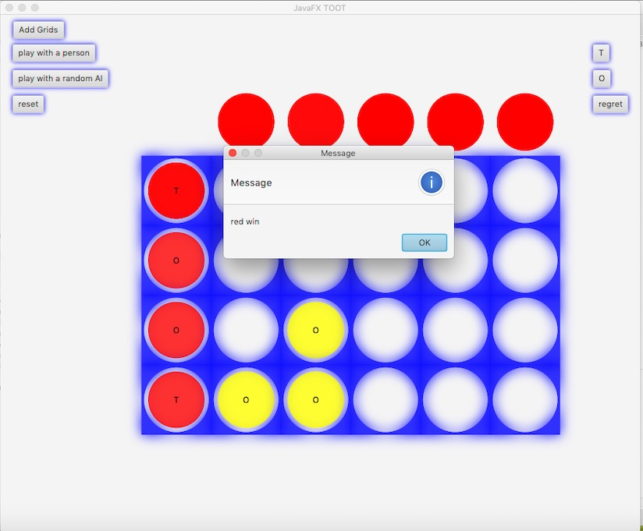

Now let’s reset and play connect 5.

The initial board is larger, and with different game rules.

Have fun!

